|  |
| --- |
| NAME: Ayush Vinod Upadhyay  ROLL NO: I025  SAP ID: 60003220131  BRANCH: Information Technology  BATCH: 1 |

**EXPERIMENT NO – 8**

Aim: To implement multiple inheritance using interfaces and method overriding.

Problem Statement 1: WAP to implement three classes namely Student, Test and Result. Student class has member as rollno, and read(). Test class has members as sem1_marks and sem2_marks and read(). Result class has member as total. Create an interface named sports that has a member score (). Derive Test class from Student and Result class has multiple inheritances from Test and Sports. Total is formula based on sem1_marks, sem2_mark and score.

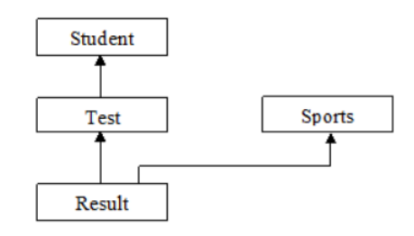

**CODE**

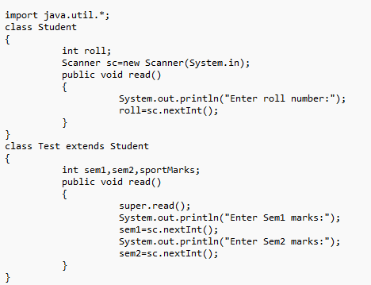

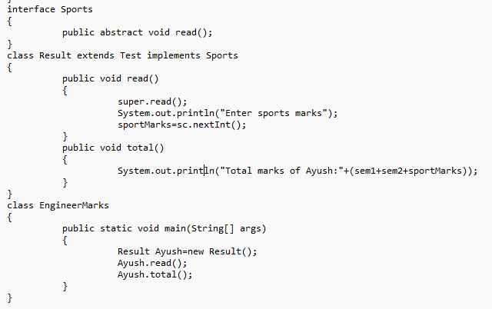

**OUTPUT**

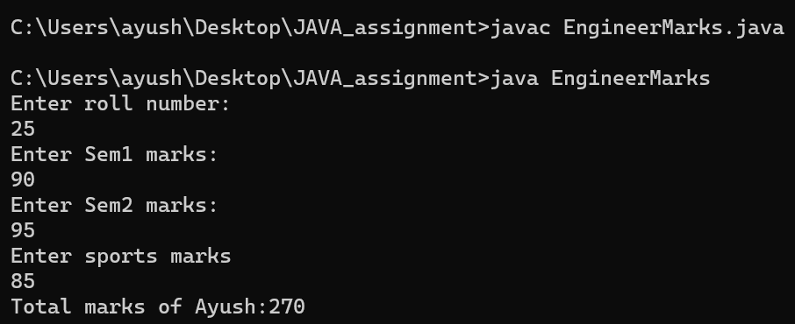

**Problem Statement 2:**

Demonstrate that a variable is constant, method cannot be overridden, class cannot be inherited using final keyword

CODE:

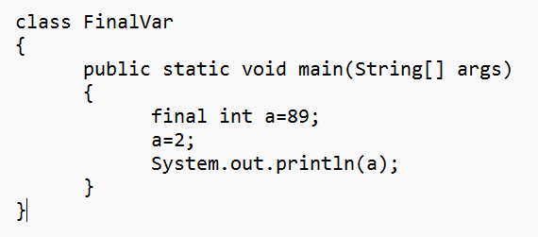

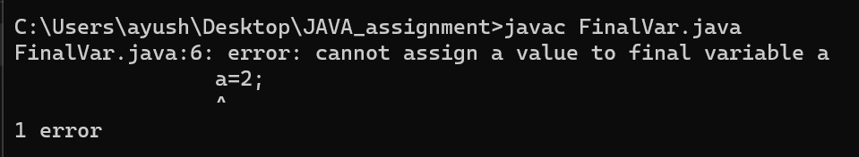

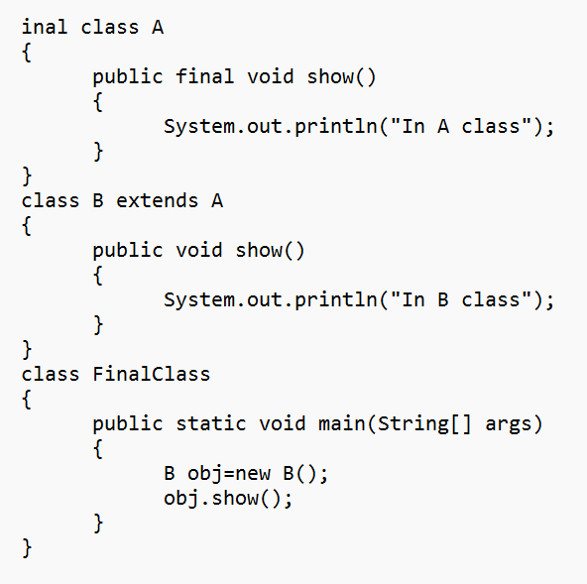

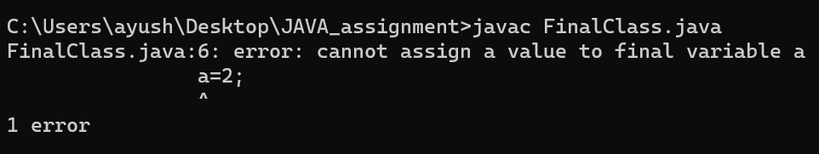

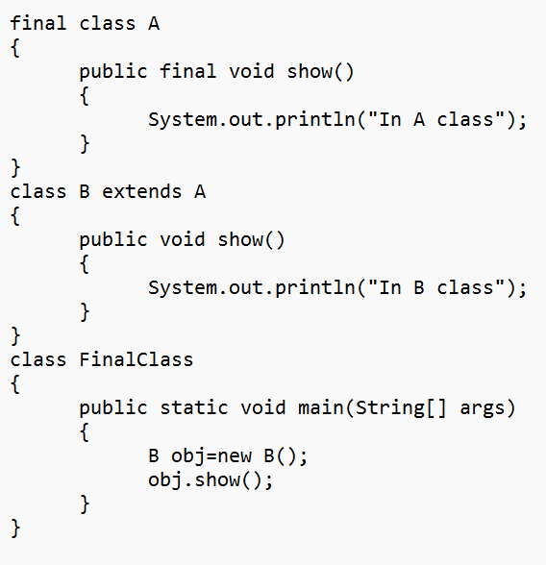

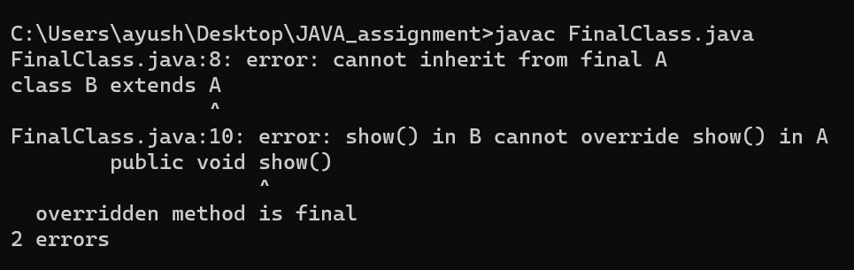

**Problem Statement 3**:

Demonstrate using a suitable example that a base class reference variable can point to a child class object using the concept of dynamic method dispatch.

CODE:

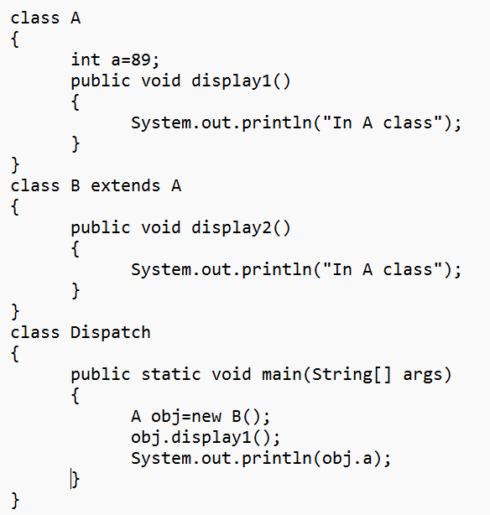

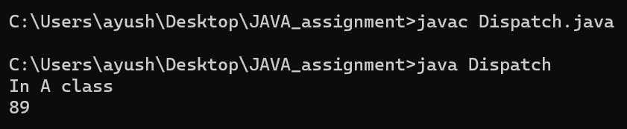

**Problem Statement 4:**

WAP to create an object of a class, delete the same object by calling System. gc () and display a message that the “object has been deleted”.

CODE:

